-------------------------------
HomeEquity Bank
Email
-------------------------------

Who is this email for? Clients who are 55+ and considering downsizing to boost retirement income.
Instructions to send the email
- Copy and paste the Email Subject Line below.
- Replace any red font with the correct information.
- Copy and paste the Email Body text below into your email system.
- Press Send.

If you have any questions, please contact your Business Development Manager.

Email Content | Subject Line

- Copy the following line of text: Discover an Alternative to Downsizing for Your Retirement
- Paste the line into the subject line of the email you want to send

Email Content | Body

- Copy the following paragraphs of text and insert them into the body of a new email draft.

Dear <Name>,
Are you considering downsizing during your retirement years? It's a choice many Canadians contemplate as their children leave the nest. Downsizing seems like an obvious way to relocate to a smaller, more affordable residence and unlock funds from the sale of your home, potentially having a positive impact on your retirement lifestyle.
However, before you make a move, there are downsides to consider. For example, the following is a cost analysis of selling a $1,000,000 home in Toronto.
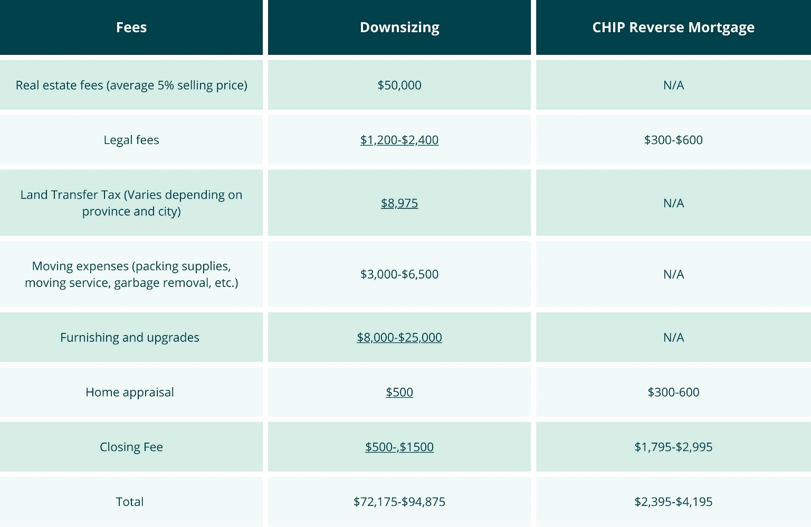
If you decide to downsize, you may be spending $72,175 to $94,875, reducing your equity from the home sale.
Emotional costs, such as deciding what possessions to keep and leaving a cherished family home filled with memories, should not be underestimated.
A downsizing alternative: The CHIP Reverse Mortgage
I want to introduce an alternative to downsizing: the CHIP Reverse Mortgage by HomeEquity Bank. The CHIP Reverse Mortgage allows you to access up to 55% of your home's equity in tax-free cash while staying in your beloved home. This money can boost your retirement finances and fund home renovations for aging in place. Plus, there are no required monthly mortgage payments, making the CHIP Reverse Mortgage a popular solution among Canadians 55+.

Contact me to learn how the CHIP Reverse Mortgage can help you save on the stress and expense of downsizing and live the retirement of your dreams.

Sincerely,
<Broker Signature and Title>

