-------------------------------
HomeEquity Bank
Social Post
-------------------------------

***More detailed instructions for how to post on various social platforms begins on page 2***

Post | Highlight and copy the text below - Remember to edit and personalize the call to action before posting.

Caption for your post is below

Want to help your loved ones with their goals and dreams? Contact me today to learn more about how the CHIP Reverse Mortgage can help you!
______________________________________________________________________________

Image| Save and upload image into your post

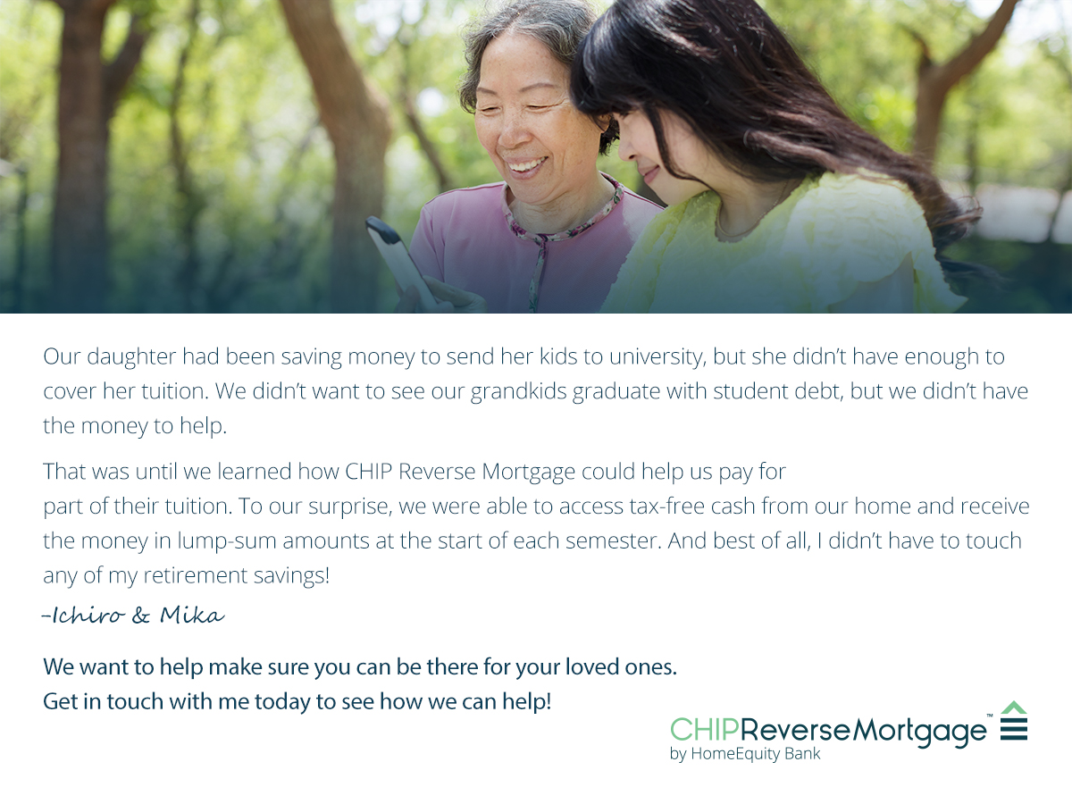

Instructions | How to post on Facebook

- Highlight, right-click and press copy on post, found on page 1
- Right-click and press save as picture on the image
- Login to your Facebook account and start a new post by clicking on Create a Post
- Paste the post. Remember to edit and personalize the call to action before posting
- Upload the image that you saved, to the post
- Click Post
______________________________________________________________________________

Instructions | How to post on Twitter

- Highlight, right-click and press copy on the post, found on page 1
- Right-click and press save as picture on the image you want to use, found on page 1
- Login to your Twitter account and start a new tweet by clicking on the compose box, at the top of your home timeline
- Paste the post. Remember to edit and personalize the call to action before posting. When editing, ensure your post is within the 280-character limit for Twitter.
- Upload the image that you saved, to the post
- Click Post
______________________________________________________________________________

Instructions | How to post on LinkedIn
For desktop

- Highlight, right-click and press copy on the post, found on page 1
- Right-click and press save as picture on the image you want to use, found on page 1
- Login to your LinkedIn account and start a new post by clicking on Start a Post
- Paste the post. Remember to edit and personalize the call to action before posting.
- Upload the image that you saved, to the post.
- Click Post
___________________________________________________________________________

Instructions | How to post on Instagram

- Highlight, right-click and press copy on the post, found on page 1
- Right-click and press save as picture on the image you want to use, found on page 1. Send to your mobile device by emailing the photo to yourself and saving it onto your phone from there.
- Login to your Instagram account and start a new post by clicking on the new post icon at the bottom center of your home timeline
- Select the image you saved and press next
- Paste the post into the caption box and remember to edit and personalize the call to action before posting.
- Click Share

