-----------------------------------------------------------------
HomeEquity Bank
Social Post
-----------------------------------------------------------------

Instructions | How to post on Facebook

- Highlight the copy below, right-click and press copy on the post

Did you know? More than 90% of Canadians 55+ want to age in place at home, but new research from Ipsos in Canada shows six in 10 say they can’t fully cover the costs of in-home care. And while 22% of Canadians 55+ plan to tap into their home’s equity to cover in-home care costs, even more (30 percent!) say they didn’t even know that option is available to them. With a reverse mortgage, you can access the equity from your home while increasing your monthly cash-flow, tax-free. Get the facts! Contact me today to learn more.

- Right-click and press save as picture on the image

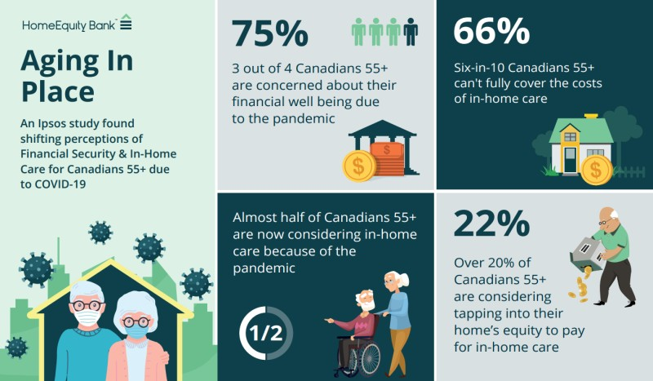

- Login to your Facebook account and start a new post by clicking on Create a Post
- Paste the post. Remember to edit and personalize the call to action before posting
- Upload the image that you saved, to the post
- Click Post
______________________________________________________________________________

Instructions | How to post on LinkedIn
For desktop

- Highlight the copy below, right-click and press copy on the post:

Did you know? More than 90% of Canadians 55+ want to age in place at home, but new research from Ipsos in Canada shows six in 10 say they can’t fully cover the costs of in-home care. And while 22% of Canadians 55+ plan to tap into their home’s equity to cover in-home care costs, even more (30 percent!) say they didn’t even know that option is available to them. With a reverse mortgage, you can access the equity from your home while increasing your monthly cash-flow, tax-free. Get the facts! Contact me today to learn more.

- Right-click and press save as picture on the image

- Login to your LinkedIn account and start a new post by clicking on Start a Post
- Paste the post. Remember to edit and personalize the call to action before posting
- Upload the image that you saved, to the post.
- Click Post
___________________________________________________________________________

